Title Text using capital letters for the principal words – 24xxx (the assigned Abstract number)
John Smith¹, Jane Smith², and Albert Flemming³ (etc.)
¹Affiliation Author 1 (Corporate Affiliation)
²Affiliation Author 2 (only if different from Author 1)
³Affiliation Author 3 (only if different from Authors 1 and 2)
(Please DO NOT include address, phone number, or email address)

ABSTRACT
The Abstract text goes here (no reference citations should be provided in the Abstract and all acronyms need to be spelled out unless listed in the WMS Approved Acronym list available on the resources and forms page of our website.
Font is 11-pt Times New Roman and text is justified between the 2.54-cm (1-inch) left and right margins. Page top and bottom margins are 2.54-cm (1-inch).

FIRST-ORDER HEADINGS (no numbering of headings)
The first-level headings text goes here. First level headings are used for the ABSTRACT, the INTRODUCTION and all subsequent main topic headings throughout the Paper, including the REFERENCES heading.

Second-Order Headings (no numbering of headings)
The second-level headings text goes here. Second-level headings are used under first-level headings only.

Below is an example equation created with Microsoft Word’s™ Equation Editor [1].

${\left(x+a\right)}^{n}=\sum_{k=0}^{n}{\left({n \atop k}\right)x^{k}a^{n-k}}$ (Eq. 1)
Figures and Tables
The following are examples of figures and tables. - The preference is to place the figure or table number and title centered. Tables and figure illustrations must be numbered and explained and referenced in the text of the Paper.
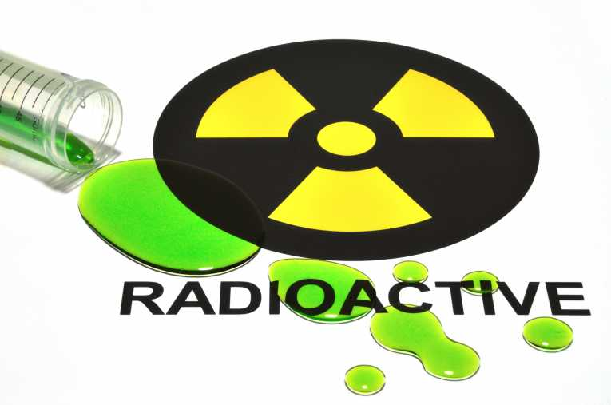
Figure 1. Radioactive Image.

Table 1. Table Name Goes Here.
Column Header 1^{A} | Column Header 2 | Column Header 3
Row name goes here | x | x
Row name goes here | x | X
^{A} Example of table footnote

Footnotes:
ª Microsoft Word™ is a trademark of the Microsoft Corporation in the United States and/or other countries.

REFERENCES
References [2], [3], and [4] are not illustrated in the preceding text of these instructions but are provided below as examples of the formats for books, journal papers, and proceedings papers, respectively.
1. Microsoft Word’s Equation Editor, Microsoft Word™.
2. M. P. Brown and K. Austin, Title of Book, pp. 25–30, J. SMITH, Ed., Publisher Name, Publisher City, Publisher State (2004).
3. M. P. Brown and K. Austin, “With or Without Title of Paper,” Title of Journal, 36, 102 (2004).
4. R. T. Wang, “Title of Paper,” Proc. Title, Location of Meeting, Date of Meeting, Vol. No., p. No., Publisher of Proceedings (2004).

ACKNOWLEDGMENTS

All acknowledgments from the Author should appear in this final section of the Paper.

